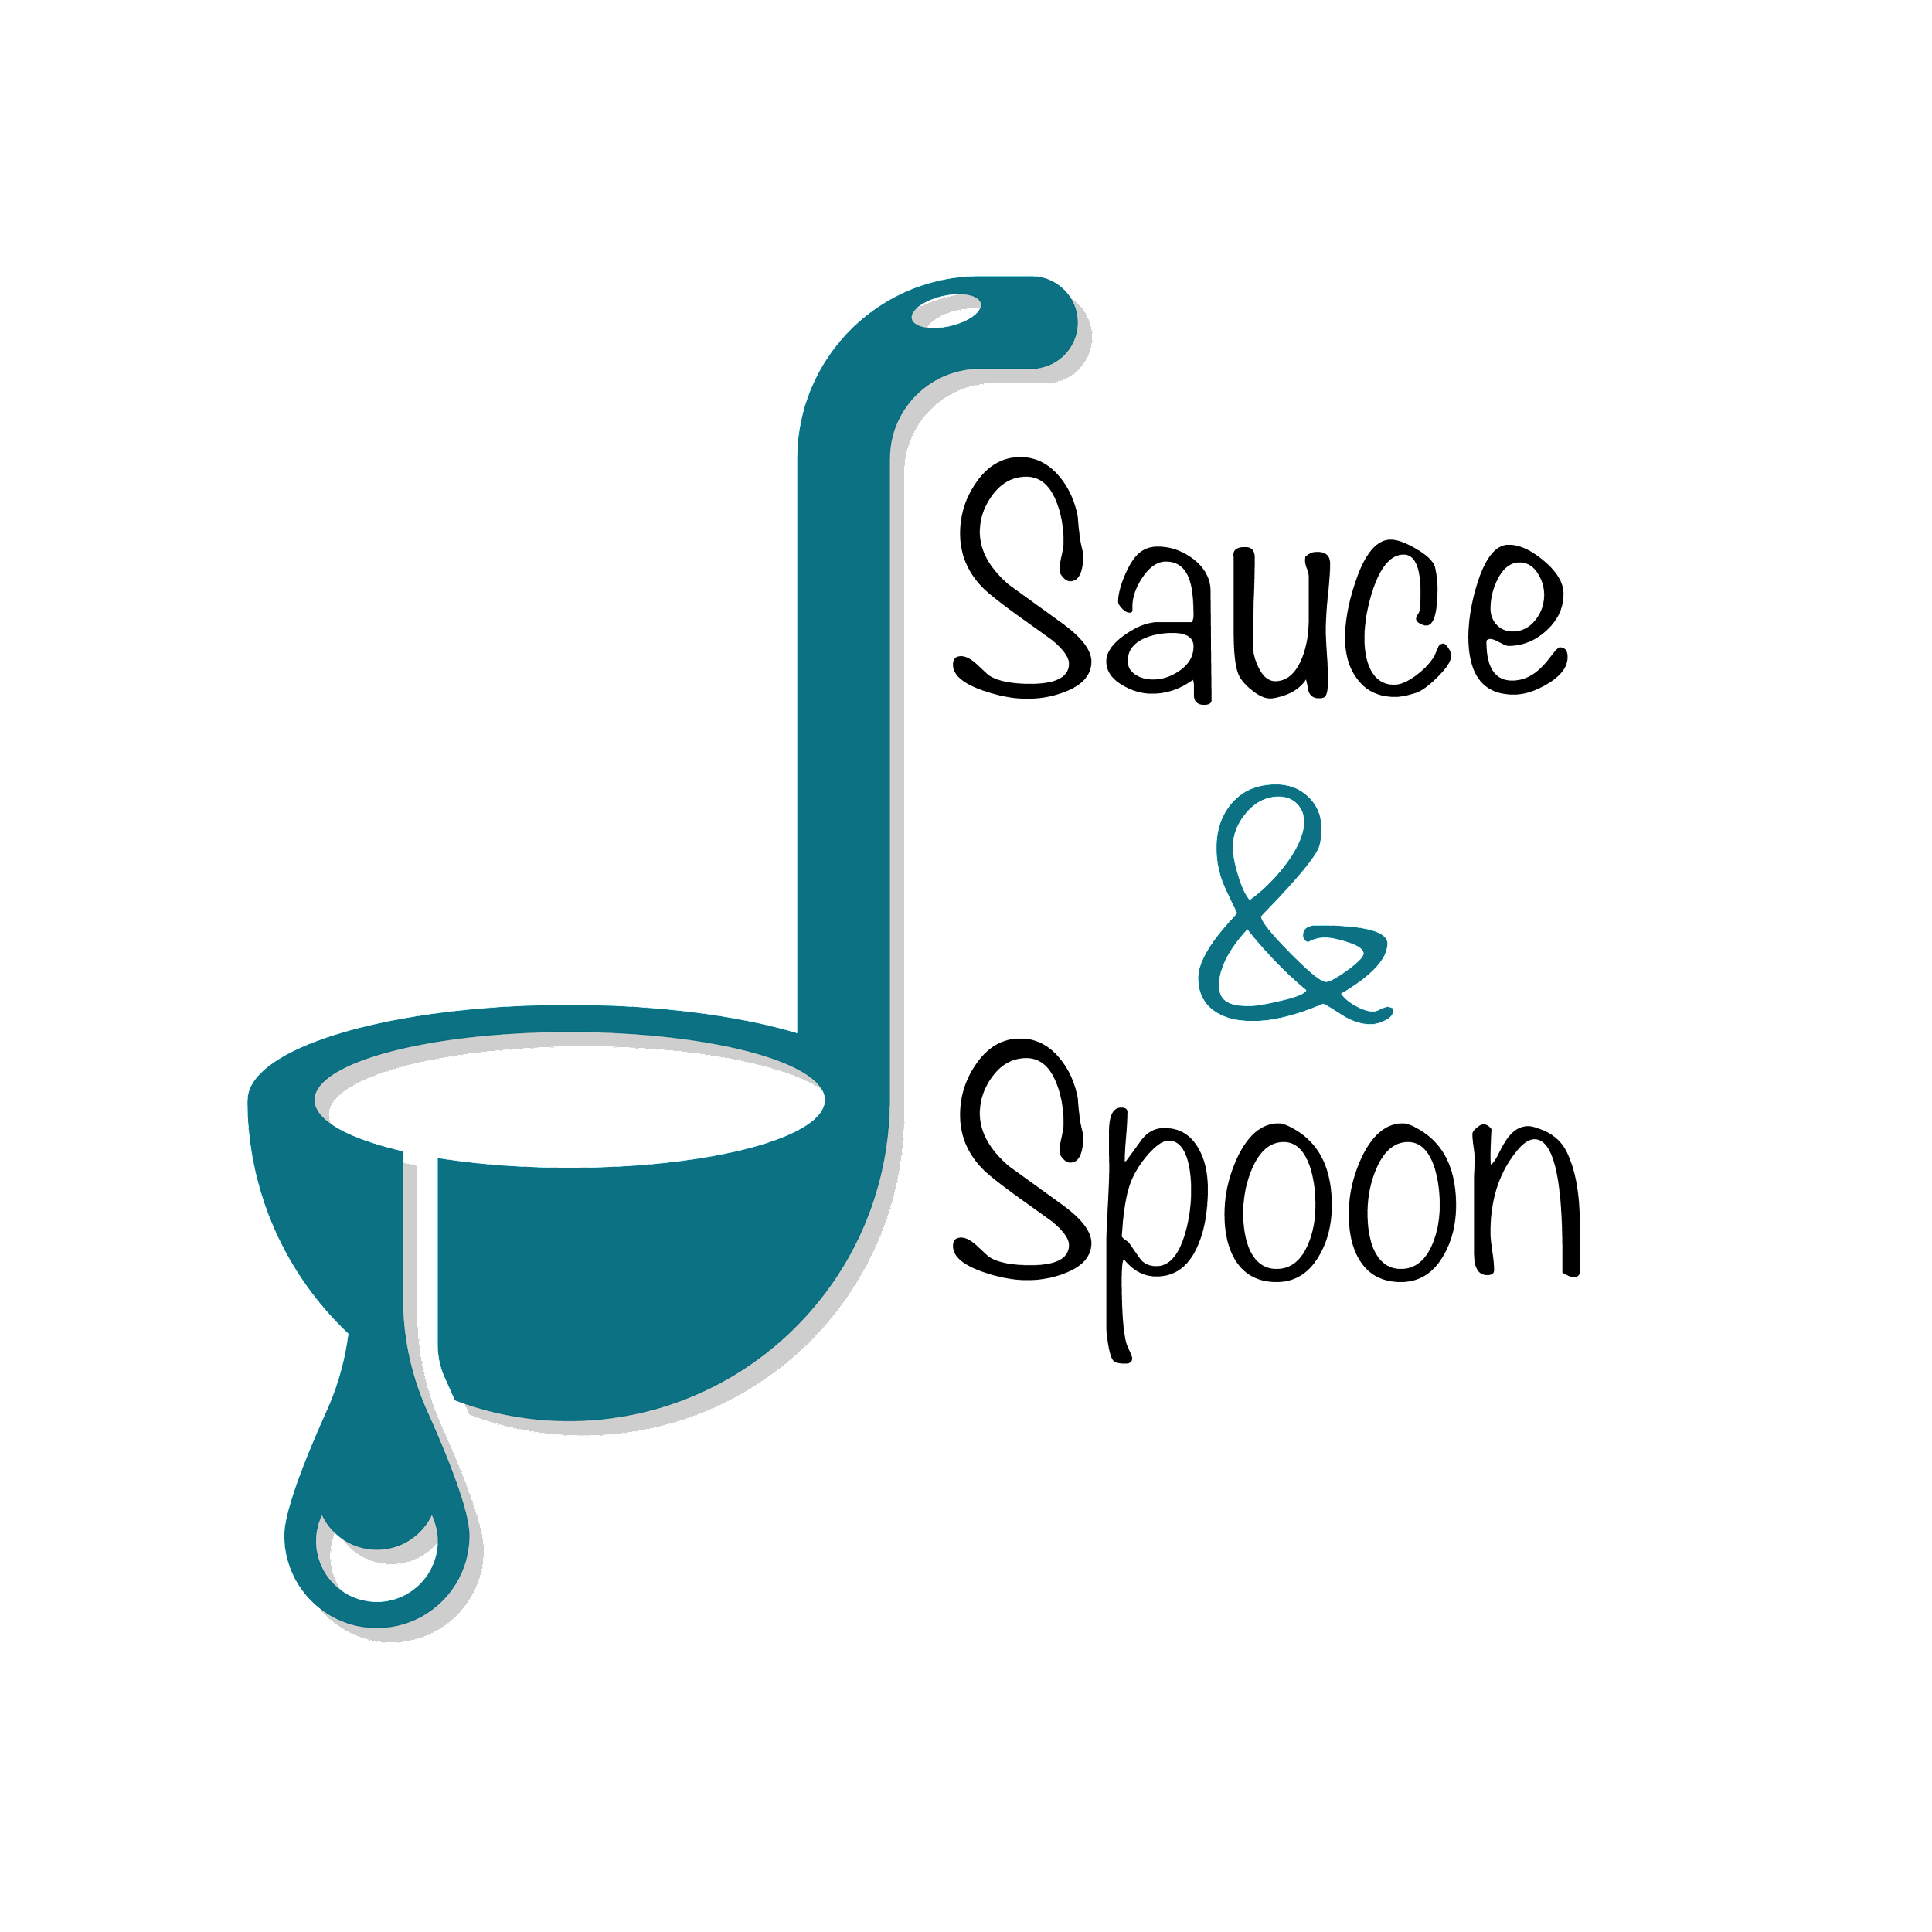

Project Charter: [Table top Menu Tablets]

DATE: [09/01/2022]

|  |
| --- |
| **Project Summary** |
| Sauce & Spoon plans to launch a pilot project roll out of tabletop menu tablets at two of our restaurant locations, Sauce & Spoon North and Sauce & Spoon Downtown. The new menu tablets will allow the restaurant to serve more guests in less time and will also provide valuable data that will help Sauce & Spoon meet its business goals. |

|  |
| --- |
| **Project Goals** |
| * Increase the sales of the product mix by upselling appetizers and bump up sales by 10% in North location and 20% in Downtown location by end of Q2. * Decrease average table turn time by about 30 minutes by the end of Q2, resulting in decreased customer wait time. * Increasing average daily guest counts by 10% by reducing table turn time. * Reduce food wastage by 25% by end of Q2 by allowing tablets to communicate specific guest requests to the kitchen directly. * Train the staff on the new process going to be adopted. * Reduce bad customer reviews. * Increase the average check total to $75 across all locations by selling more appetizers and specialty beverages by end of Q2, resulting in increased profits. |
|  |

|  |
| --- |
| **Deliverables** |
| * Roll out of the tablets in the bar with the tablet package including menu add- ons and coupons. * A tablet software that is compatible with the existing systems and easily configurable to make the integration as seamless as possible. * Each table serves a minimum of four parties within a span of 5 hours. * Real-time tablet communication directly with the kitchen about the menu modification. * A plan for training the staff. |

|  |
| --- |
| **Scope and Exclusion** |
| **In-Scope:**   * Pilot rollout of tabletop menu tablets at two restaurant locations, Sauce & Spoon North and Sauce & Spoon Downtown. * Tablets to be implemented in the bar area to drive faster turnover. * Inclusion of metrics that capture staff’s performance for the food waste goal. * Employee satisfaction to decrease to turn over rate.   **Out-of-Scope:**   * Change of company policy on order returns to due error. * Other areas in the restaurant except for the bar area is considered out of scope for this project. * Hiring kitchen staffs * All other items which are not explicitly defined as in scope is considered out of scope. |

|  |
| --- |
| **Benefits & Costs** |
| **Benefits:**   * Reduce costs in staffing, order size etc. * Improved customer satisfaction and retention by providing timely and quality service. * Bump up the sales of appetizers as the result of increase in product mix. * Increased average daily guest counts by a margin of 10%. * Reduce the food wastage. * Increased revenue due to the increase in average check total value, increased guest count & increased sales. * The tablets will provide the restaurant with clear data points on customer ordering and an integrated point-of-sale system to help guide decision-making in the future     **Costs:**   * Training Materials and fees : $10,000 * Hardware & Software implementation across locations : $30,000 * Maintenance (IT fees through EOY) : $5000 * Updated website & menu design fee : $5000 * Other customization fees : $550 |
|  |

|  |
| --- |
| **Appendix:** |
| * Reallocating some of the payroll from FOH budget to hire more cooks to meet high demand. Open up two part time line cook roles as a temporary solution until there is some data that can accurately project revenue increases and how the tablets impact table turn time. * Decrease guest wait time-If tables turn more quickly, wait times will decrease naturally. Solutions to de discussed. * Increase employee satisfaction to reduce turnover rate. Metrics involved in measuring the satisfaction is to be discussed. * Change in company return policy due to error. As a solution, this was later moved to an operations’ discussion. |